LATAM Certificates

Solution Design

Document_v1.0

Document Change Record

Version | Date | Author | Organization | Role/Function | Change Details/Comments (If any)
1.0 | April 18, 2023 | Karin Kascakova |  | Developer

Distribution List

Name | Department | Designation
Paola Andrea Venegas | Customer Service | Senior Representative
Fabio Oliveira | Customer Service | Manager

Document Sign-Off Requirements

Name | Department | Designation | Approved Date
Paola Andrea Venegas | Customer Service | Senior Representative
Fabio Oliveira | Customer Service | Manager

Contents
Document Change Record 2
Distribution List 2
Document Sign-Off Requirements 2
1. Overview 4
2. Purpose 4
3. Automation /BOT Project details 4
4. Runtime Guide 5
4.1 Process Flow diagrams 5
4.2 List of RPA packages/plugins used for Automation same ass PDD 5
4.3 Process Details. 6
5. BOT Details 8
5.1 Bot Workflow(s) & other components. 8
5.2 Environment and other details of BOT 26
5.3 Reports: 27

Overview

The Solution Design Document (SDD) is created for every business process that is automated using the RPA technology. The SDD document needs to be reviewed and updated for every change requested and applied to the automation process. This document will provide a technical snapshot and must always reflect the latest design and key features of the automation workflow. This document is filled/modified by the resource who automated/modified the BOT of the business process and reviewed prior to handover to RPA Support.

Purpose

The purpose of the document is to record the outcome, specific to the BOT developed and its subcomponents. This document is meant for the RPA Dev Team, RPA Support and the BSAs to provide a snapshot of the automated process details and different components. It can as well serve developers to have a quick glance at the setup, before diving into the code to troubleshoot and perform code changes.

Automation /BOT Project details - Dispatcher

# | Item | Details
1 | Project name | LATAM_CS_Certificates_Dispatcher
2 | Version | 1.0
3 | Robot type  (Attended/Unattended) | Unattended
4 | Single/Concurrent | Single
5 | Is Orchestrator used? (Yes/ No) | Yes
6 | Scalable? (Yes/ No)  (can the process be run by multiple robots in parallel?) | Not Applicable  Not Required as of now.

Runtime Guide

Process Flow diagrams

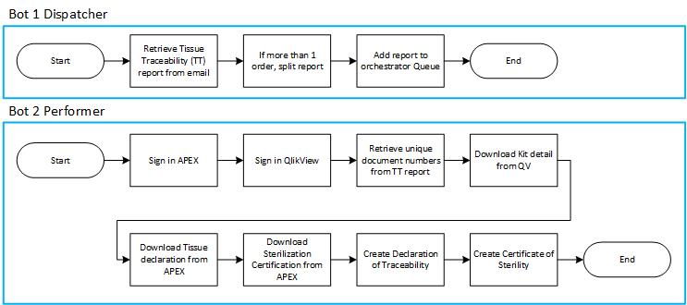

List of RPA packages/plugins used for Automation same as PDD

Include the list of packages and the high-level description for each of them, to explain each one`s purpose:
# | Package name | High Level description
1 | Workflow Manager Activities | Workflow Manager 1.0 provides activities that fall under two categories: activities for working with expressions and data types, and activities for messaging, communications, and building the logic of your workflow applications.
2 | UiPath Excel Activities | Executes excel related operations using the Open Office XML format (XLSX)
3 | UiPath system activities | This package is used to install all the system activities
4 | UiPath Automation Activities | The UI Automation activities package contains all the basic activities used for creating automation projects. Package is used to perform all the user interface operations.
5 | CreateServiceNowIncident | This package is used to create Service now ticket
6 | DownloadAndReadConfigFileFromStorageBucket | Download and read config file from storage bucket
*Add more rows to the table to include all the project names and version. No fields should be left empty. Use “n/a” for the items that don`t apply to your project.

Process Details.

Details of the automated process:
# | Item | Details  (Fill in with free text. If the section does not apply to your automation, mark the field as “n/a”. No empty fields. )
1 | Production environment details | Production Server:  Username:  Password:
2 | Prerequisites to run | VDI Machine & UiPath Robot are available  Excel application is installed on VDI Machine  Exchange server is accessible with BOT account  Google chrome is available  Access to APEX application  Access to QlikView dashboard Kit to Components
3 | Input Data | Tissue Traceability report
4 | Expected Output (output data) | Records from the report loaded into 3 different queues
5 | How to start the automated process? | BOT is Triggered in orchestrator,
6 | Reporting  (queues reporting, Kibana or another platform) | N/A
7 | Manual Error Handling  (roll back or manually complete failed transactions). Procedures to reset the item. Ex “set status as investigating” | Bot handles all the Exceptions by itself. For all the Exceptions Bot sends email to BU and creates ticket in SNOW. In case of change in selectors manual intervention is needed and the bot will send email to BU and create ticket to support team if such issue is raised.
7 | a. How to resume the process in case of error | - Unless an unhandled exception is thrown from bot end, bot continues to run processing next record.  - Errors and exceptional records are written in summary report for exceptions.  - Bot send email to BU and creates ticket in SNOW in case of error. The support team fixes the issue and reruns the bot.
7 | b. How to manually fix transactions with errors | All the exceptions during the transaction process are emailed to BU and ticket is created in SNOW and support team will fix the issue.
9 | Use of Orchestrator | Yes
9 | Password policies  (Specific compliance requests?) | In Compliance with Edwards
9 | Stored Credentials:  (Never hardcode credentials in the workflow) | Passwords are stored in CyberArk
9 | List of Asset Names:  (Follow naming convention ProcessName_AssetName) | LATAM_Certificates_Apex_Credentials  LATAM_Certificates_Apex_URL  LATAM_Certificates_BucketName  LATAM_Certificates_ConfigPath  LATAM_Certificates_ConfigSheets  LATAM_Certificates_ConfigSupportMail  LATAM_Certificates_Disp_ConfigFileName  LATAM_Certificates_Disp_ConfigSubject  LATAM_Certificates_Disp_domain  LATAM_Certificates_Disp_ServerCredentials  LATAM_Certificates_Dispatcher_BusinessMail  LATAM_Certificates_Dispatcher_ConfigFileName  LATAM_Certificates_Dispatcher_ConfigSubject  LATAM_Certificates_Dispatcher_domain  LATAM_Certificates_Dispatcher_ServerCredentials  LATAM_Certificates_JDE_Credentials  LATAM_Certificates_JDE_URL  LATAM_Certificates_Performer_BusinessMail  LATAM_Certificates_QV_Credentials  LATAM_Certificates_QV_URL  LATAM_Certificates_ServerCredentials  LATAM_Certificates_SNOWImpact  LATAM_Certificates_SNOWUrgency  LATAM_Certificates_SupportMail
9 | List of Queues Names  (Follow naming convention ProcessName_QueueName) | LATAM_Certificates_Dispatcher  LATAM_Certificates_Performer
9 | Schedule details: | Mon – Sun at 4PM and 10PM CET

BOT Details

Bot Workflow(s) & other components.

"Framework\InitConfig"
Initialize Config file from Orchestrator Storage Bucket
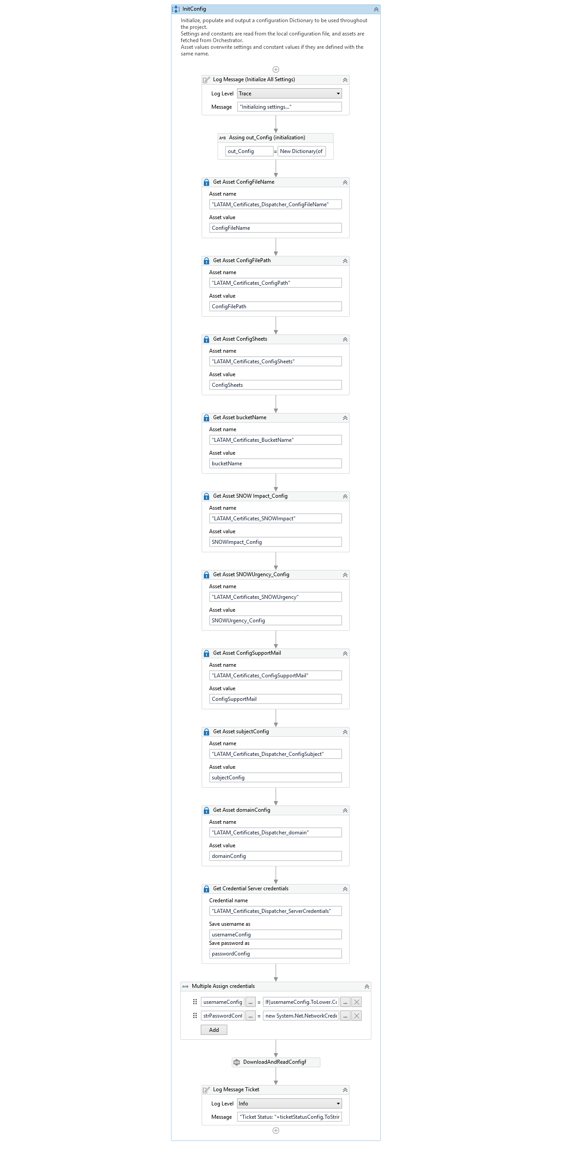

"Email\RetrieveReport"
Retrieve Tissue Traceability report from email attachment, save it to shared drive, and add it as a transaction item to Orchestrator Queue.
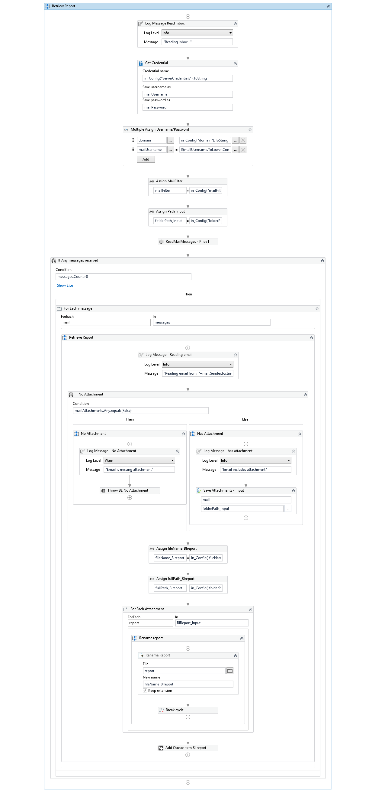
"HelperMethods\CreateSNOWticket"
Automatically create SNOW Incident in case of an exception
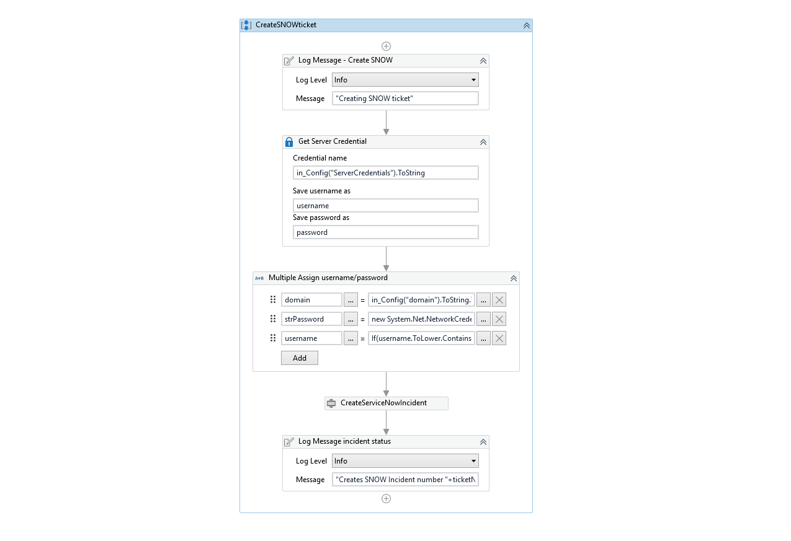
"HelperMethods\Process_NumberOfOrders"
Retrieve number of orders in Tissue traceability report
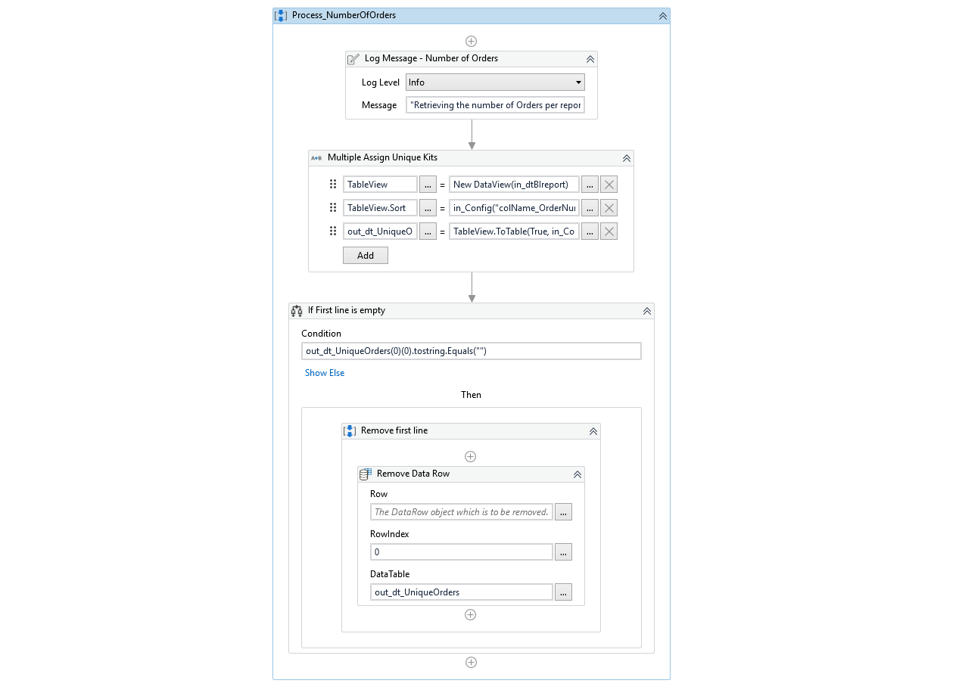
"HelperMethods\Process_ReadAndSanityCheck"
Read Tissue Traceability report from shared drive ad perform a number of sanity checks to ensure the report is not corrupted
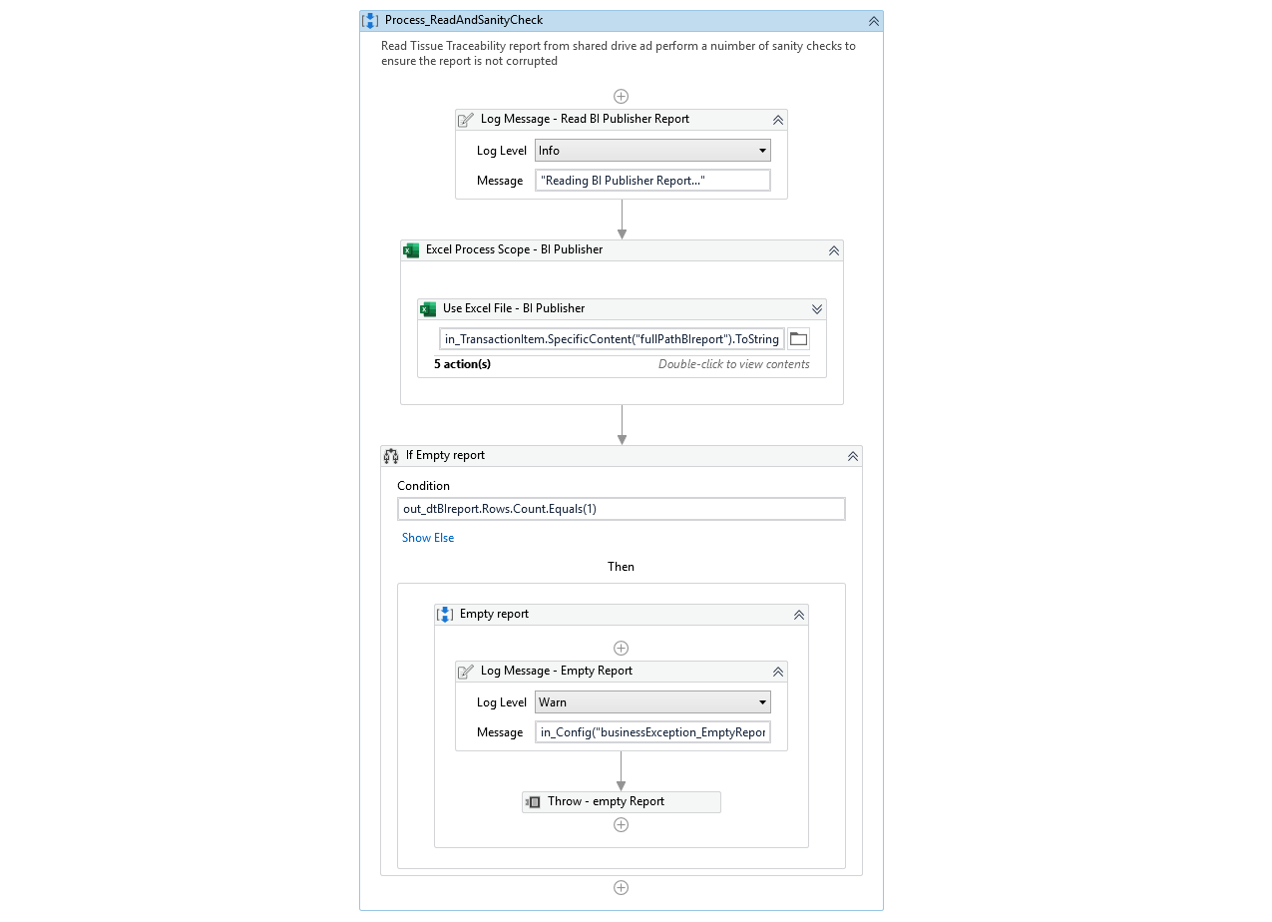
"HelperMethods\RenameTissueTraceability"
Rename Tissue Traceability report to be unique for each transaction
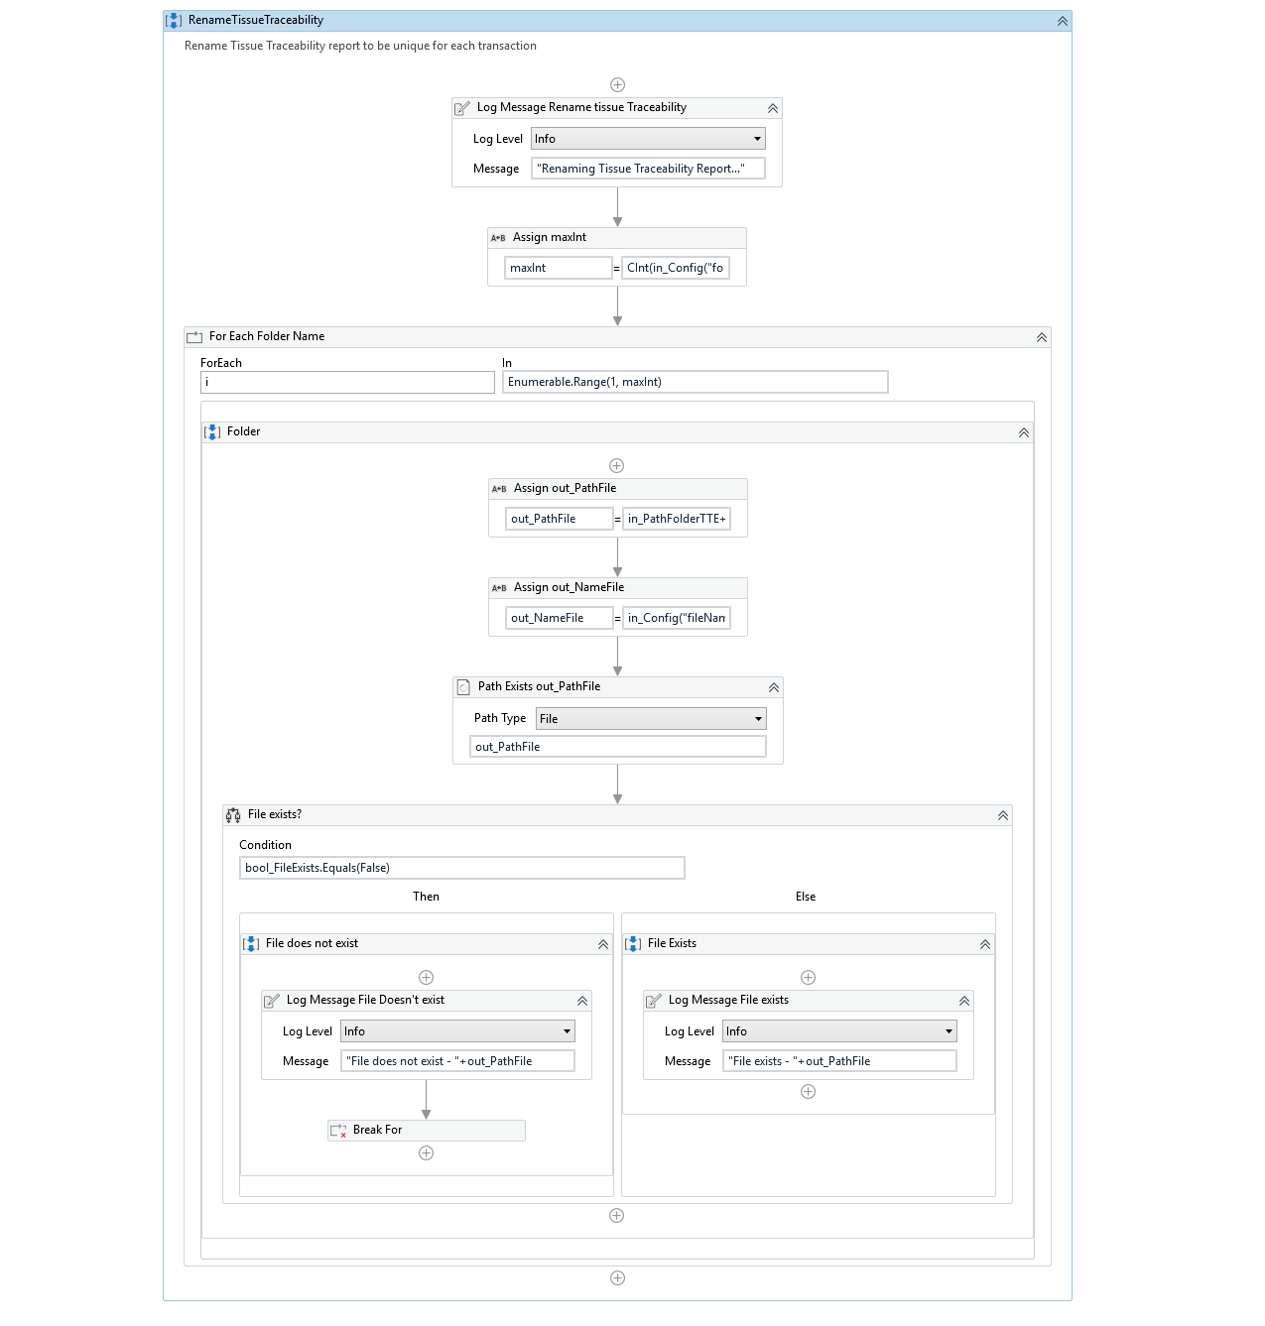
"HelperMethods\SendbusinessNotification"
In case of failed transaction inform business of this exception
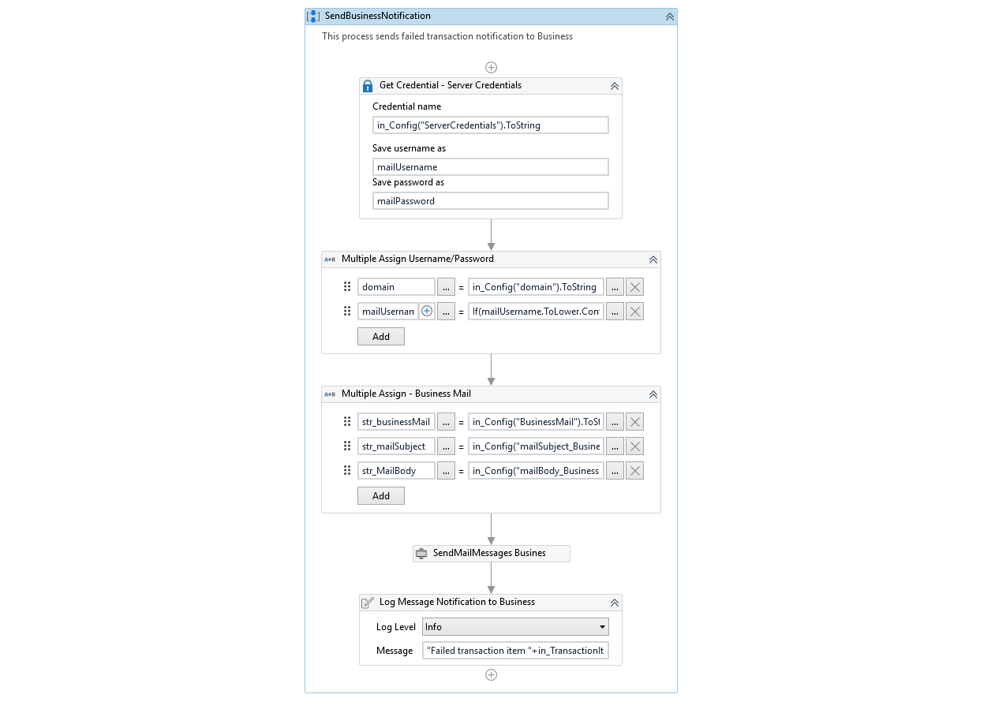
"HelperMethods\SplitTissueTraceability"
If more than 1 order is included in the Tissue Traceability report, split it into multiples
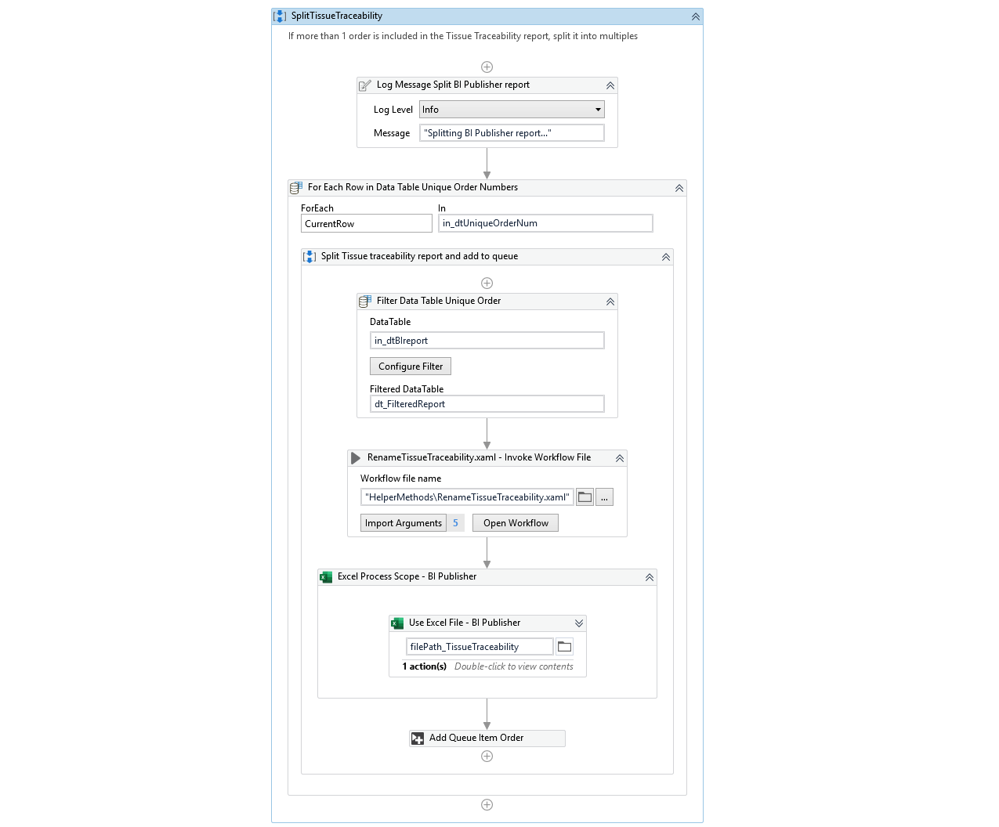

Environment and other details of BOT

# | Item name | Details  (Fill in with free text. If not applicable, mark the field as “n/a. No empty fields.)
1 | Environment used for development  (name, location, configuration details etc.) | Remote Machine: AWOR-DVUIPAPP03  Connection: CyberArk Vault
2 | Environment prerequisites  (OS details, libraries, required apps) | Remote Server, Chrome, Microsoft Excel, Exchange Server, APEX access, QlikView access
3 | Logging level | Orchestrator / info
4 | Details about automation (if the apps were automated using UI Automation, Image & Text) | Automation uses UI for APEX and QlikView web based application
5 | Can the user operate the computer while the robot is running? | VDI machine is dedicatedly used for running LATAM Certificates bot only. However, user can operate the computer.
6 | Repository for project  (where the developed project is stored) | Code is stored in the Development server and Source code repository. Developed code is also uploaded as package in Orchestrator
7 | List of reused components
8 | Logs defined in the workflows  (where Throw Activity was used or custom log message was defined) | Yes, Logs can be accessed via Orchestrator.
9 | Frequent errors found in the development phase
10 | Workarounds used in the automation phase | None.
11 | Configuration method (assets, excel file, Json file) | Excel File for Bot configurations, Assets,
12 | Configuration details  (path for input files, configuration Orchestrator assets used) | Config.xlsx, Assets in Orchestrator

Reports:
Logs and details about transactions can be obtain from Orchestrator

Automation /BOT Project details - Performer

# | Item | Details
1 | Project name | LATAM_Certificates_Performer.1.0.1
2 | Version | 1.0
3 | Robot type  (Attended/Unattended) | Unattended
4 | Single/Concurrent | Single
5 | Is Orchestrator used? (Yes/ No) | Yes
6 | Scalable? (Yes/ No)  (can the process be run by multiple robots in parallel?) | Not Applicable  Not Required as of now.

Runtime Guide

Process Flow diagrams

List of RPA packages/plugins used for Automation same ass PDD

Include the list of packages and the high-level description for each of them, to explain each one`s purpose:
# | Package name | High Level description
1 | Workflow Manager Activities | Workflow Manager 1.0 provides activities that fall under two categories: activities for working with expressions and data types, and activities for messaging, communications, and building the logic of your workflow applications.
2 | UiPath Excel Activities | Executes excel related operations using the Open Office XML format (XLSX)
3 | UiPath system activities | This package is used to install all the system activities
4 | UiPath Automation Activities | The UI Automation activities package contains all the basic activities used for creating automation projects. Package is used to perform all the user interface operations.
5 | CreateServiceNowIncident | This package is used to create Service now ticket
6 | SendMailMessages | Send email messages
7 | Edwards.UiPath.SharePoint.Activities | Store documents
8 | UiPath.Word.Activities | Create consolidated documents
9 | DownloadAndReadConfigFileFromStorageBucket | Download and read Config from storage bucket in orchestrator
*Add more rows to the table to include all the project names and version. No fields should be left empty. Use “n/a” for the items that don`t apply to your project.

Process Details.

Details of the automated process:
# | Item | Details  (Fill in with free text. If the section does not apply to your automation, mark the field as “n/a”. No empty fields. )
1 | Production environment details | Production Server:  Username:  Password:
2 | Prerequisites to run | VDI Machine & UiPath Robot are available  Excel application is installed on VDI Machine  Exchange server is accessible with BOT account  Google chrome is available  Access to APEX and QlikView
3 | Input Data | Tissue Traceability report, data in queue
4 | Expected Output (output data) | Required documents are downloaded form APEX and QlikView, consolidated into Declaration of Traceability and Certificate of Sterility, and a notification is sent to business
5 | How to start the automated process? | BOT is Triggered in orchestrator,
6 | Reporting  (queues reporting, Kibana or another platform) | N/A
7 | Manual Error Handling  (roll back or manually complete failed transactions). Procedures to reset the item. Ex “set status as investigating” | Bot handles all the Exceptions by itself. For all the Exceptions Bot sends email to BU and creates ticket in SNOW. In case of change in selectors manual intervention is needed and the bot will send email to BU and create ticket to support team if such issue is raised.
7 | a. How to resume the process in case of error | - Unless an unhandled exception is thrown from bot end, bot continues to run processing next record.  - Errors and exceptional records are written in summary report for exceptions.  - Bot send email to BU and creates ticket in SNOW in case of error. The support team fixes the issue and reruns the bot.
7 | b. How to manually fix transactions with errors | All the exceptions during the transaction process are emailed to BU and ticket is created in SNOW and support team will fix the issue.
9 | Use of Orchestrator | Yes
9 | Password policies  (Specific compliance requests?) | In Compliance with Edwards
9 | Stored Credentials:  (Never hardcode credentials in the workflow) | Passwords are stored in CyberArk
9 | List of Asset Names:  (Follow naming convention ProcessName_AssetName) | LATAM_Certificates_Apex_Credentials  LATAM_Certificates_Apex_URL  LATAM_Certificates_BucketName  LATAM_Certificates_ConfigPath  LATAM_Certificates_ConfigSheets  LATAM_Certificates_ConfigSupportMail  LATAM_Certificates_Disp_ConfigFileName  LATAM_Certificates_Disp_ConfigSubject  LATAM_Certificates_Disp_domain  LATAM_Certificates_Disp_ServerCredentials  LATAM_Certificates_Dispatcher_BusinessMail  LATAM_Certificates_Dispatcher_ConfigFileName  LATAM_Certificates_Dispatcher_ConfigSubject  LATAM_Certificates_Dispatcher_domain  LATAM_Certificates_Dispatcher_ServerCredentials  LATAM_Certificates_JDE_Credentials  LATAM_Certificates_JDE_URL  LATAM_Certificates_Performer_BusinessMail  LATAM_Certificates_QV_Credentials  LATAM_Certificates_QV_URL  LATAM_Certificates_ServerCredentials  LATAM_Certificates_SNOWImpact  LATAM_Certificates_SNOWUrgency  LATAM_Certificates_SupportMail
9 | List of Queues Names  (Follow naming convention ProcessName_QueueName) | LATAM_Certificates_Dispatcher  LATAM_Certificates_Performer
9 | Schedule details: | Mon – Sun at 4PM and 10PM CET

BOT Details

Bot Workflow(s) & other components.

"APEX\Login\ApexSignin"
Signin module to APEX
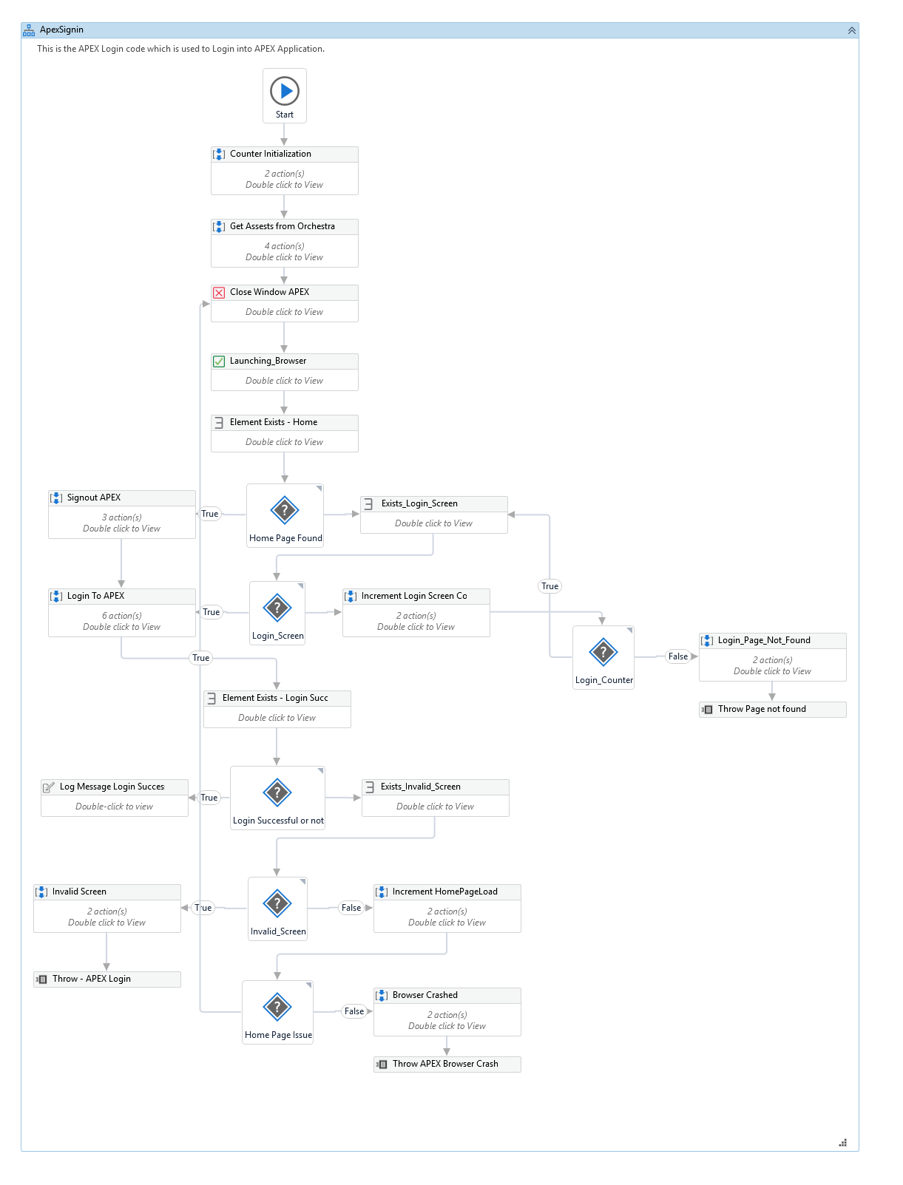
"APEX\Login\ApexSignout"
Signout module to APEX
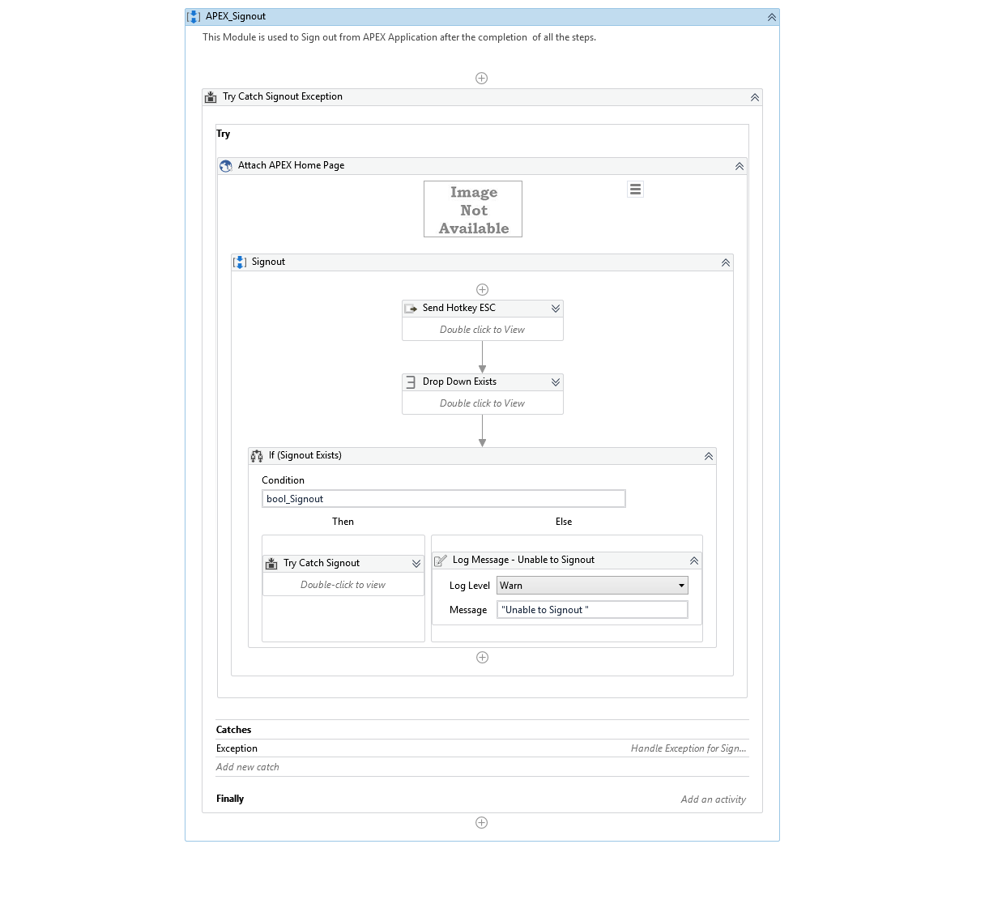

"APEX \DownloadDocument"
Download tissue declaration from APEX
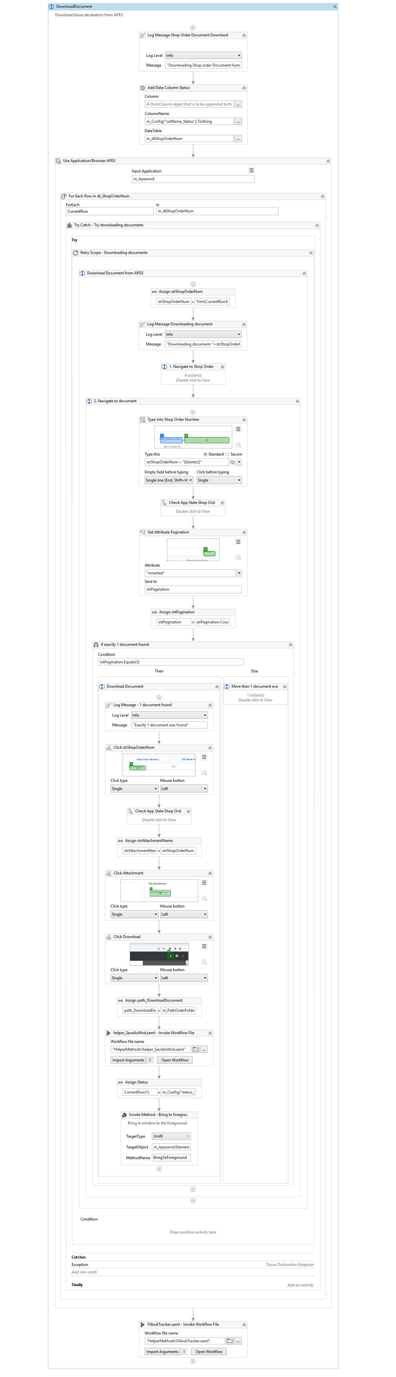
"APEX \DownloadSterilizationDocument"
Download Sterilization Certification from APEX
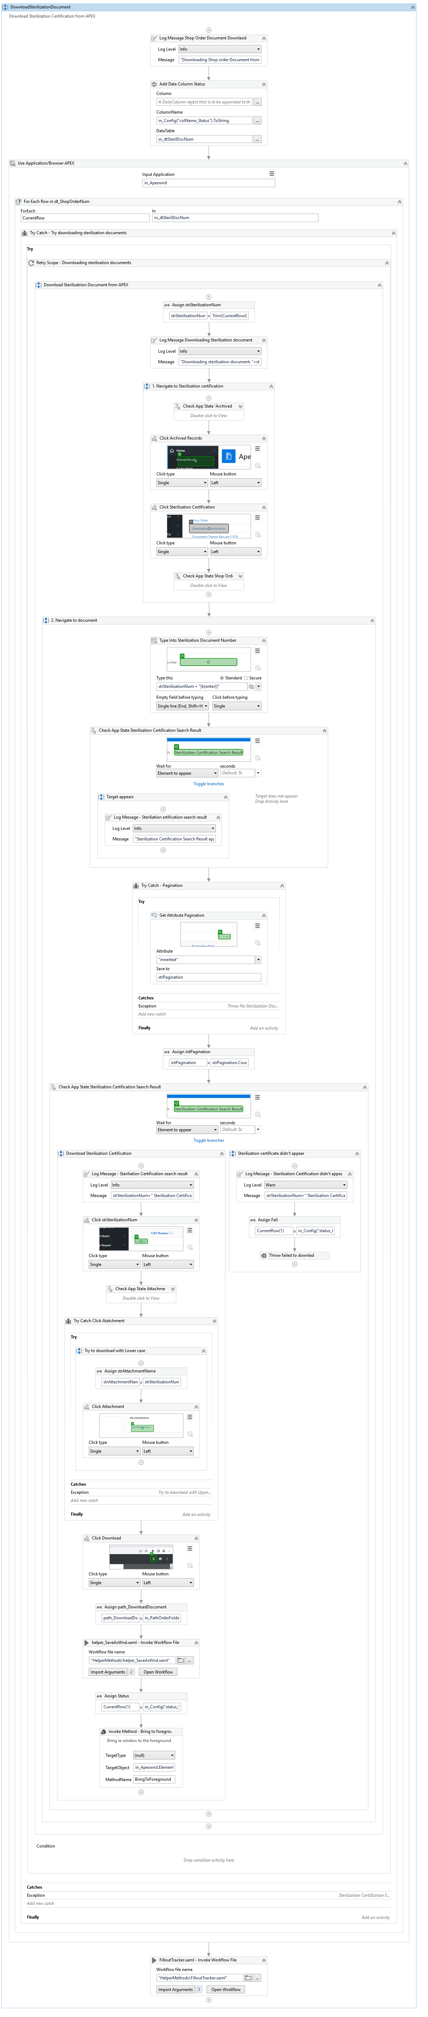
"QlikSense \QlikSignIn"
Signin module to QlikSense – Kit to Components dashboard
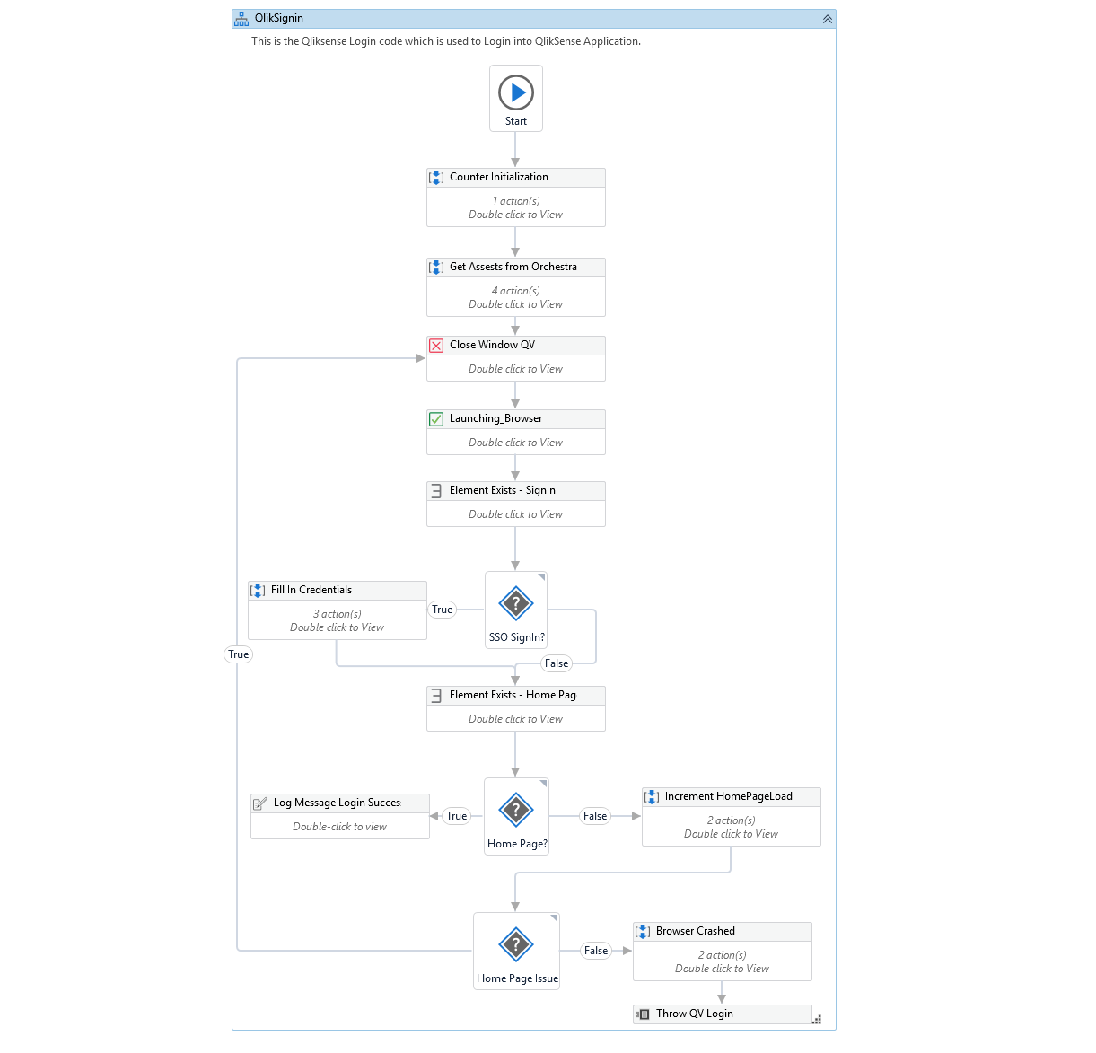

" QlikSense \DownloadKitDetail"
Download Kit Detail from QlickView
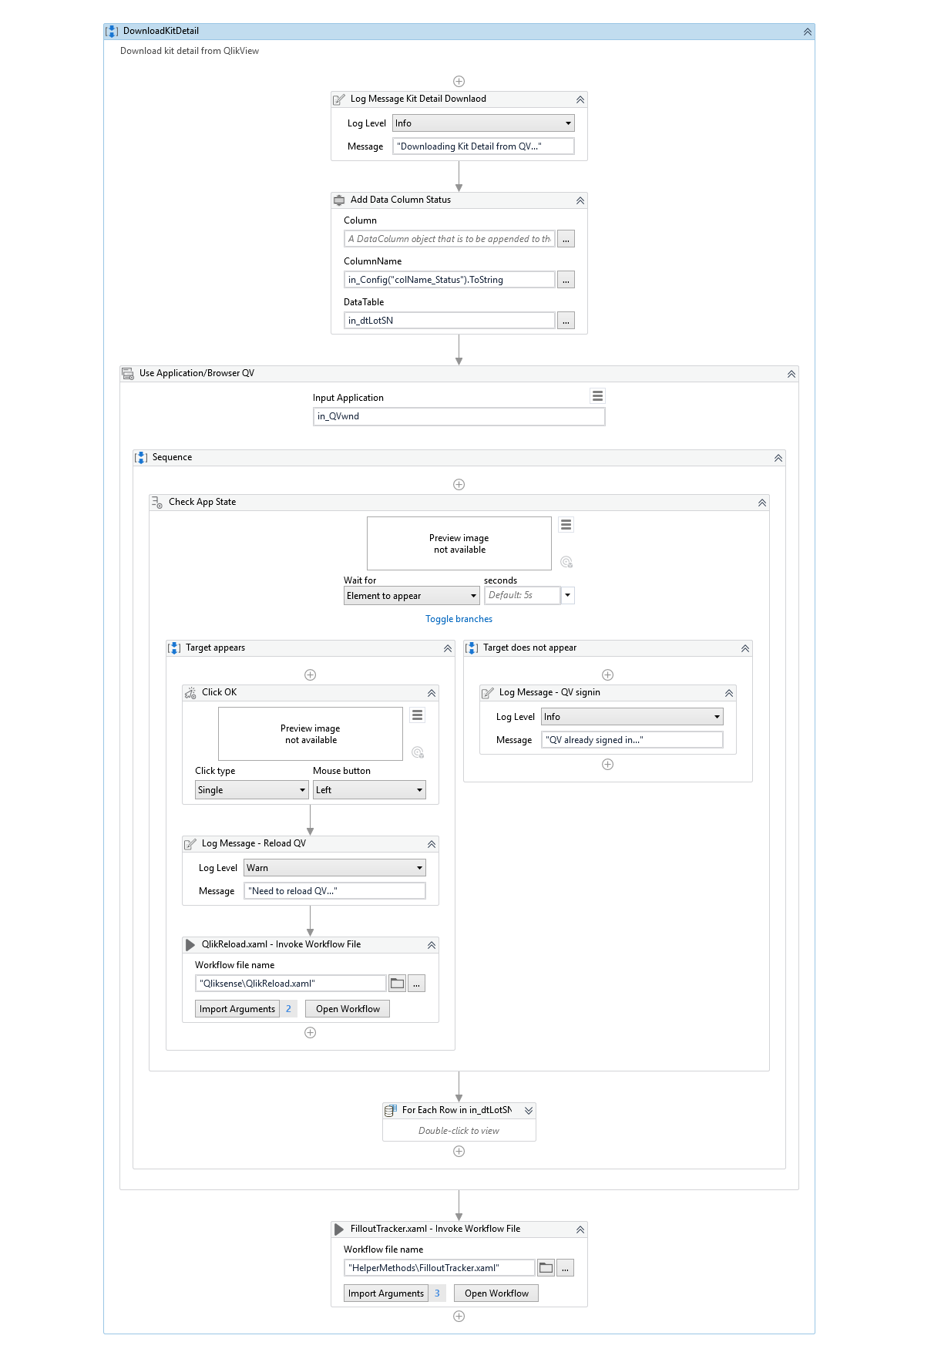
" HelperMethods\CopyTTE"
Copy Tissue traceability report to Input folder
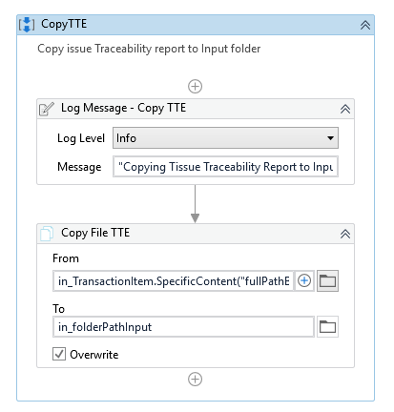
" HelperMethods\CreateCertificateOfSterility"
Create certificate of Sterility
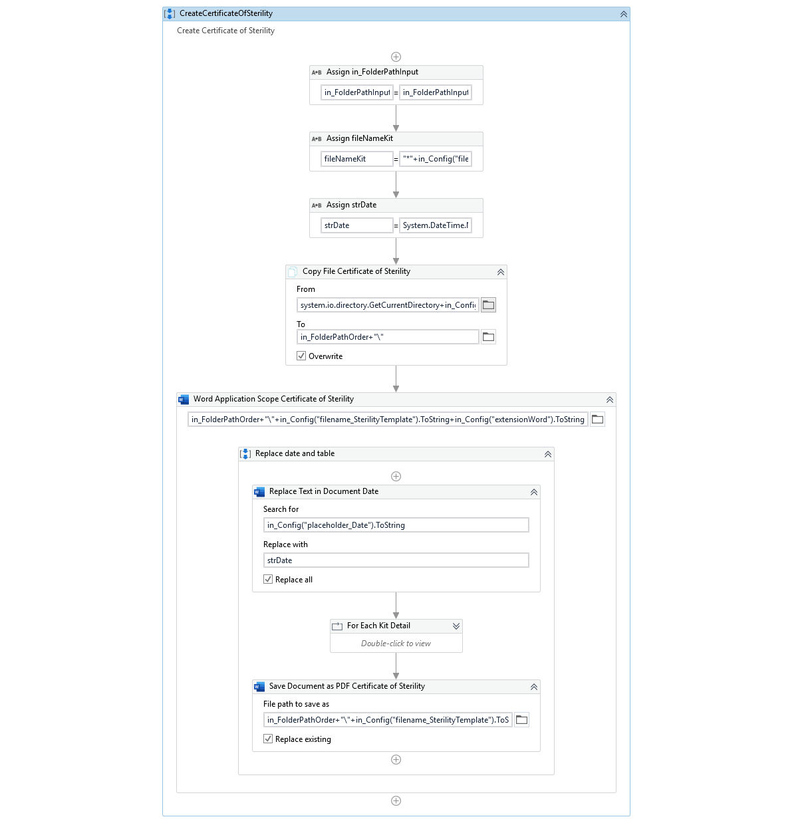
" HelperMethods\CreateDeclarationofTraceability"
Create Declaration of Traceability
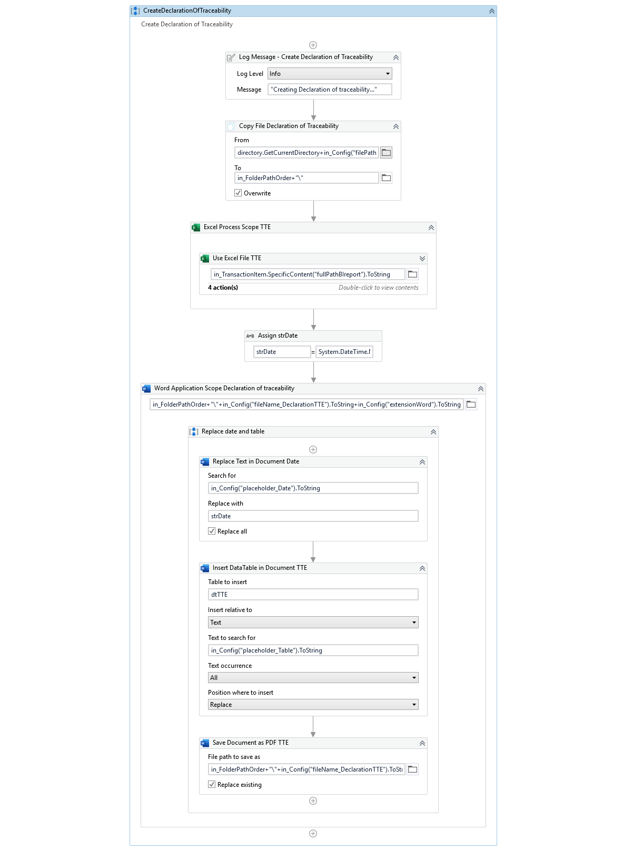
" HelperMethods\CreateFolderStructure"
Create shared folder structure
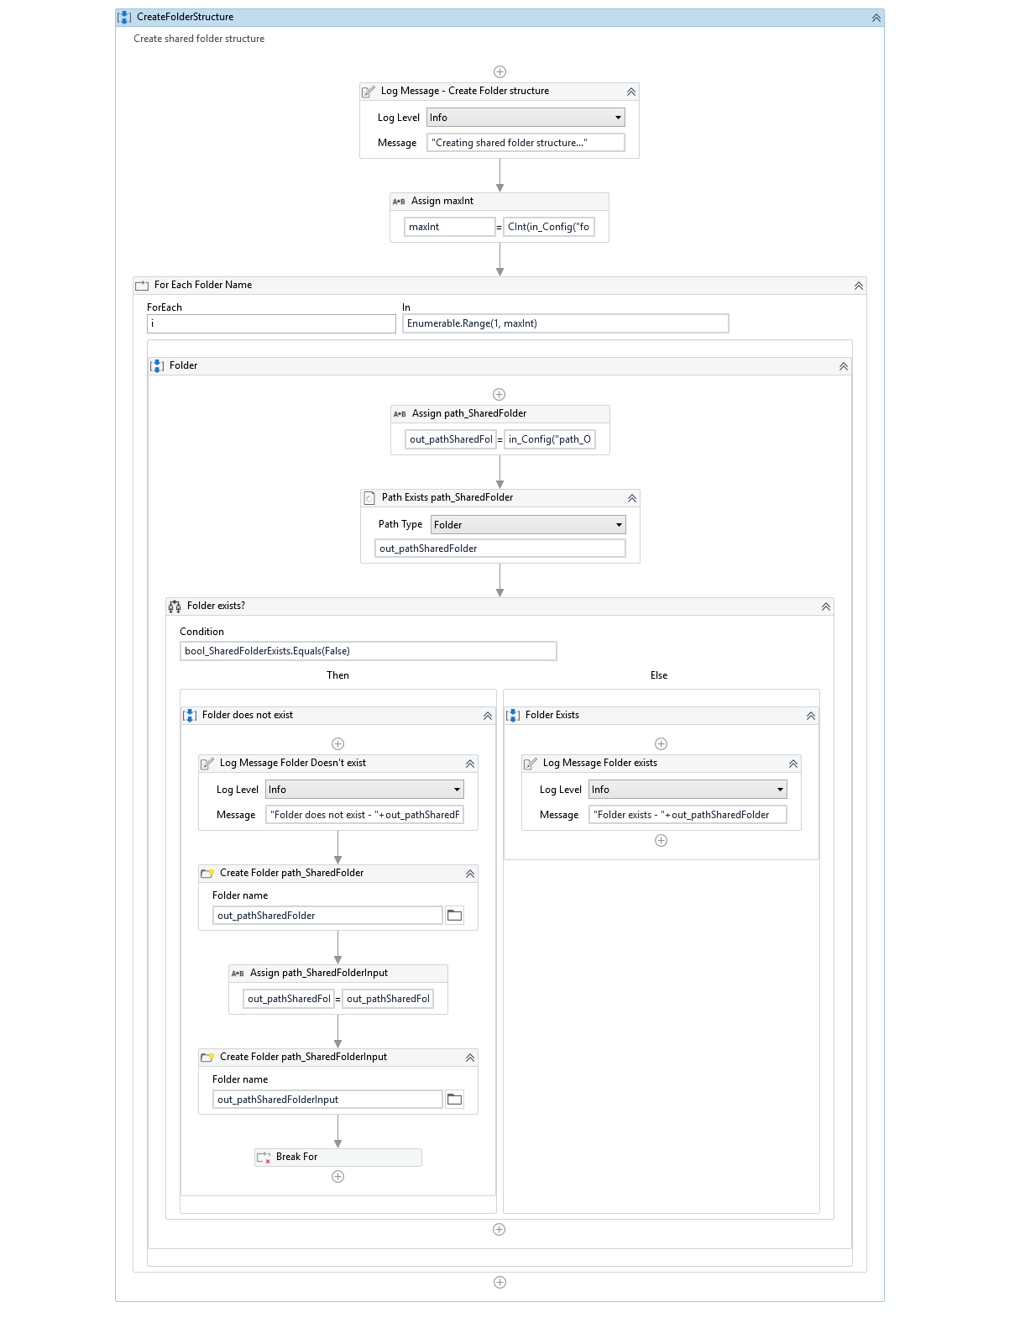
" HelperMethods\CreateTrackerExcel"
Create tracker excel file
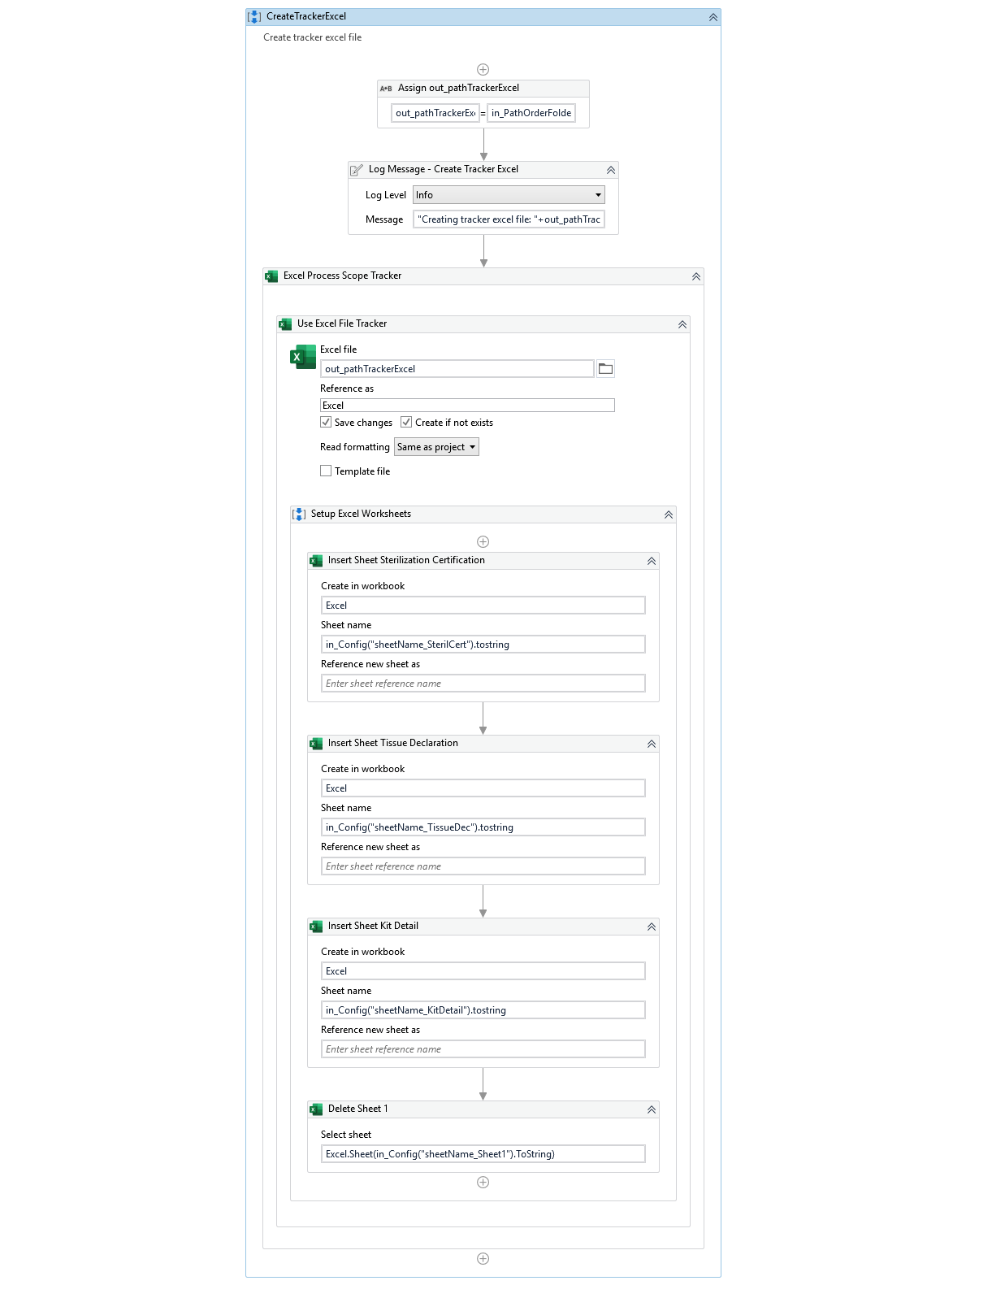
" HelperMethods\FilloutTracker"
Fill out tracker with tracking information
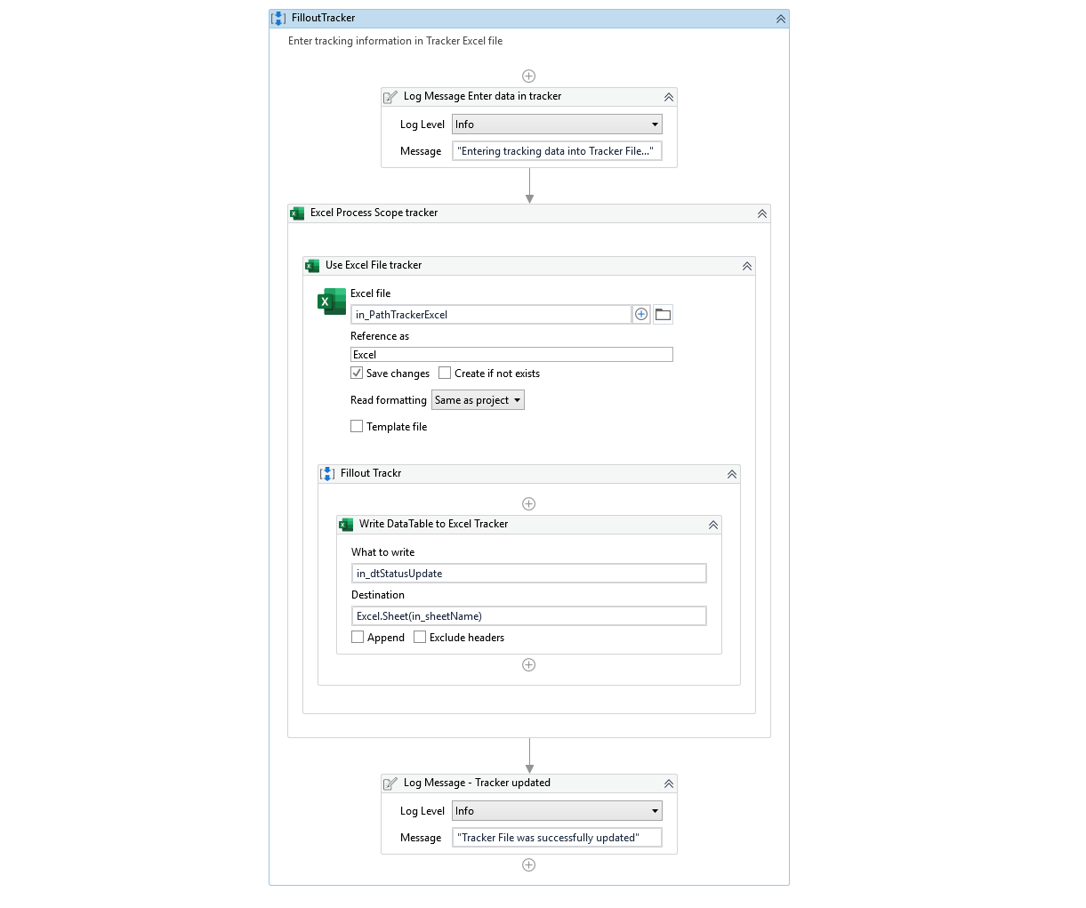

" HelperMethods\helper_SaveAsWnd"
Handle Chrome Save As window
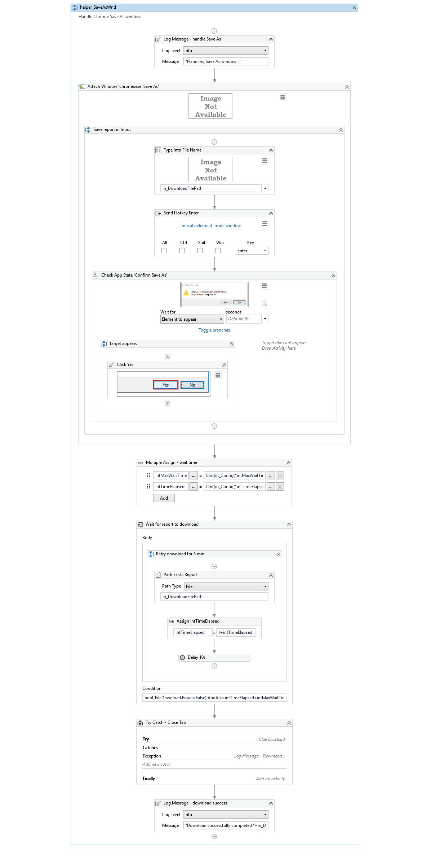
" HelperMethods\readReport_GetOrderNum"
Get Order Number
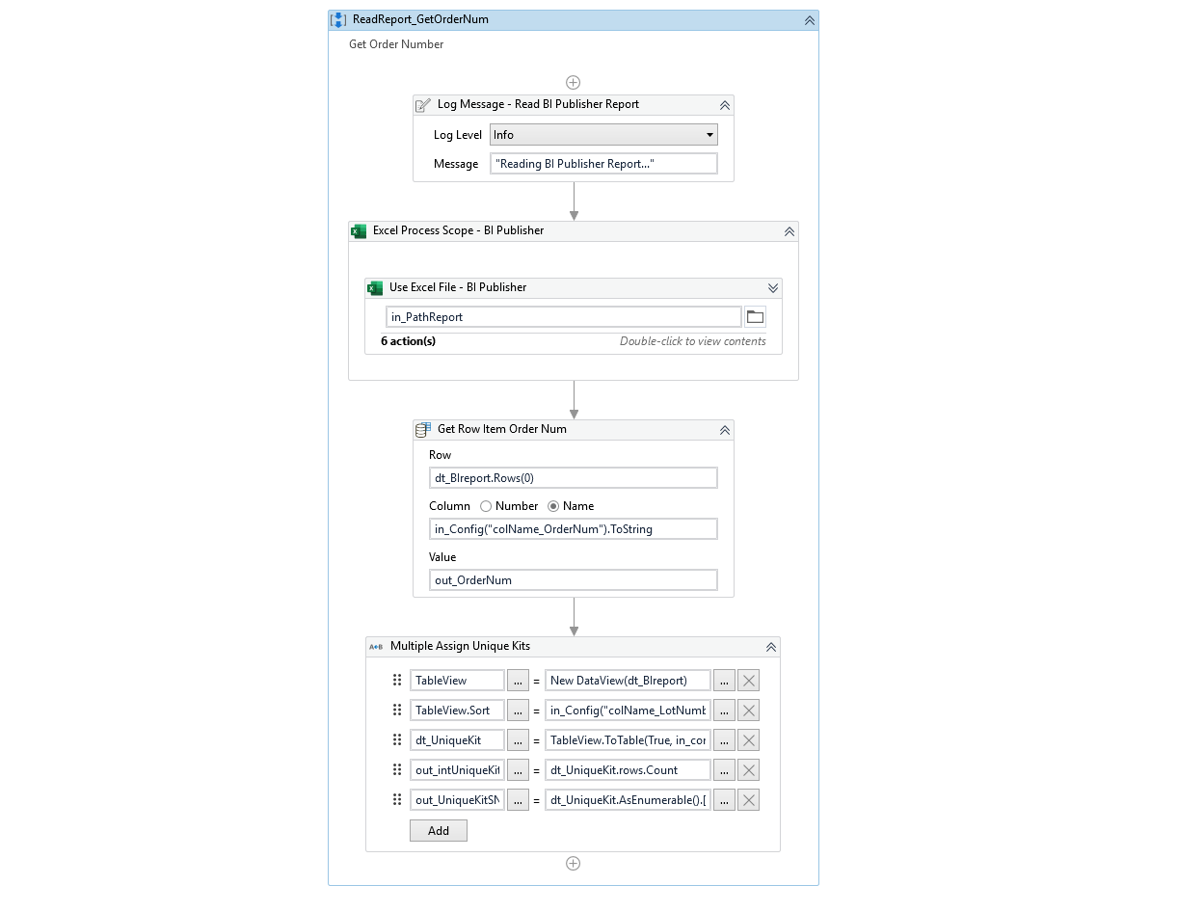
" HelperMethods\UniqueLotSerialNum"
Get list of unique Lot Serial numbers form Tissue Traceability report
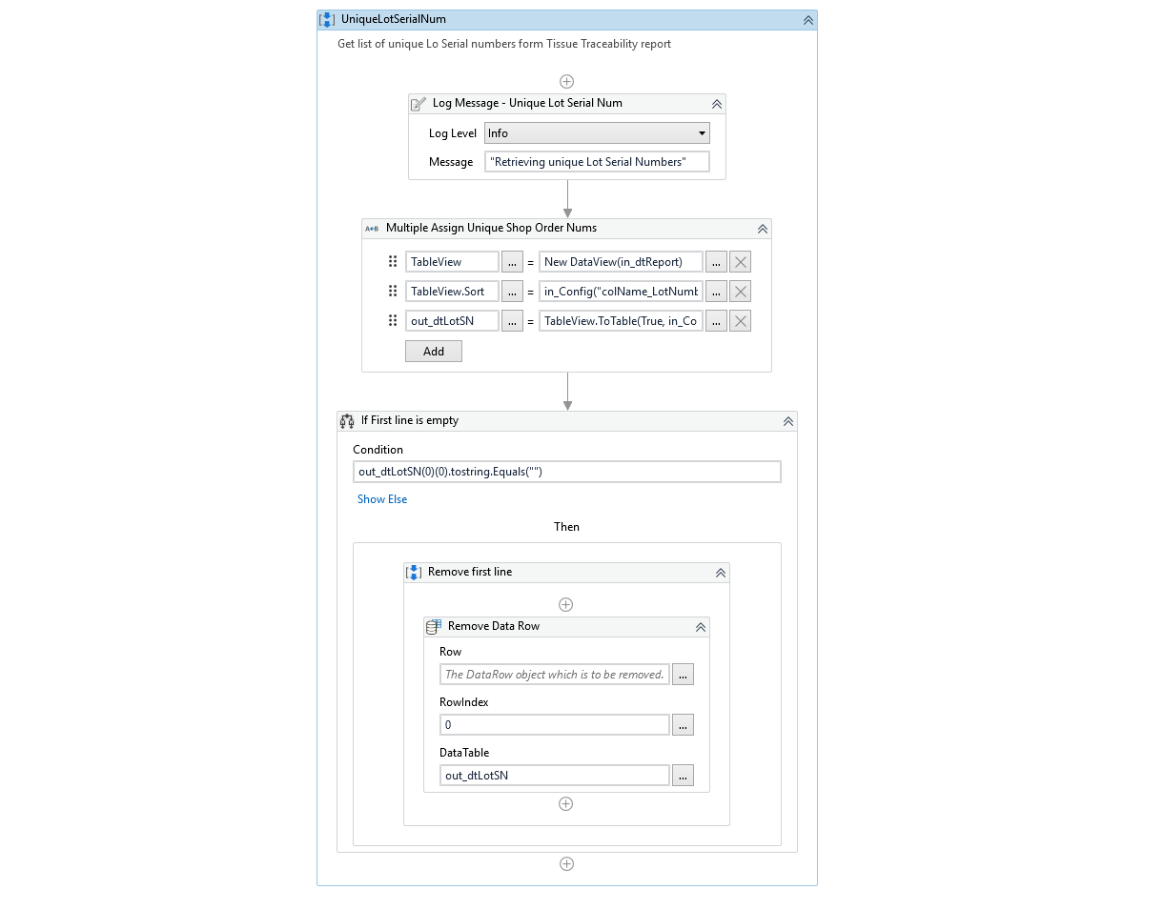
" HelperMethods\UniqueShopOrderNum"
Get list of unique Document form Tissue Traceability report
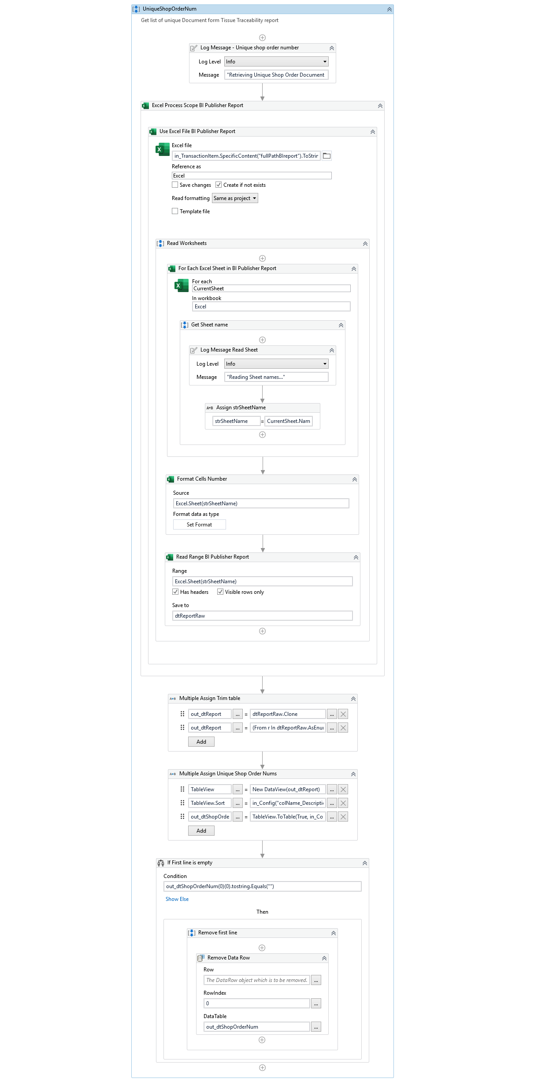
" HelperMethods\UniqueShopOrderNum"
Get list of unique sterilization documentation numbers from Tissue Traceability report
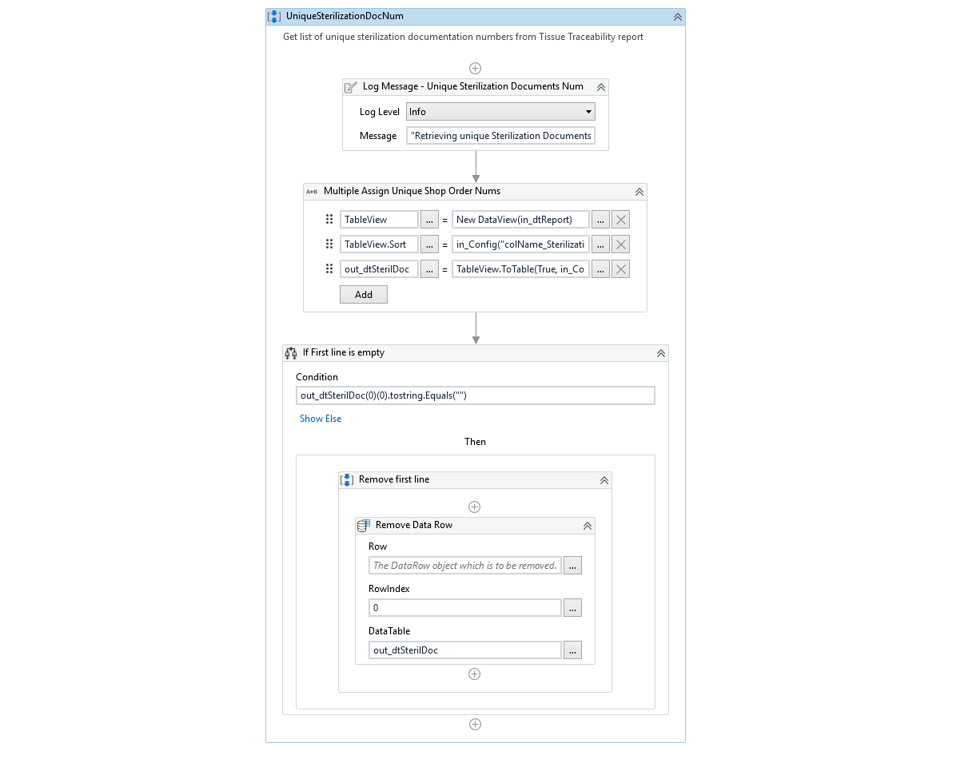

Environment and other details of BOT

# | Item name | Details  (Fill in with free text. If not applicable, mark the field as “n/a. No empty fields.)
1 | Environment used for development  (name, location, configuration details etc.) | Remote Machine: AWOR-DVUIPAPP03  Connection: CyberArk Vault
2 | Environment prerequisites  (OS details, libraries, required apps) | Remote Server, Chrome, Microsoft Excel, Exchange Server, Salesforce access
3 | Logging level | Orchestrator / info
4 | Details about automation (if the apps were automated using UI Automation, Image & Text) | Automation uses UI for QlickView and APEX web based application
5 | Can the user operate the computer while the robot is running? | VDI machine is dedicatedly used for running LATAM Certificates bot only. However, user can operate the computer.
6 | Repository for project  (where the developed project is stored) | Code is stored in the Development server and Source code repository. Developed code is also uploaded as package in Orchestrator
7 | List of reused components
8 | Logs defined in the workflows  (where Throw Activity was used or custom log message was defined) | Yes, Logs can be accessed via Orchestrator.
9 | Frequent errors found in the development phase
10 | Workarounds used in the automation phase | None.
11 | Configuration method (assets, excel file, Json file) | Excel File for Bot configurations, Assets,
12 | Configuration details  (path for input files, configuration Orchestrator assets used) | Config.xlsx, Assets in Orchestrator

Reports:
Logs and details about transactions can be obtain from Orchestrator

